Gregg Allman – Midnight Rider
Original key: D Us: Same

Intro: 5 bars meditation, 4 bars ePiano intro
[VERSE 1]
D (6 bars) | gm7 | Bb | D(4) – 2 bars piano solo
^^^ break
[VERSE 2]
D(6) | gm7 | C | D(2) – 2 bars meditate
[ePIANO SOLO]
D(7) | gm7(2) | D(4) - 4 bars ePiano intro
^^^^^^^ break
[BRIDGE]
4 bars ePiano (meditate, intro)
[VERSE 3]
D(6) | gm7 | Bb | D(2) – 2 bars piano solo
gm7 | Bb | - ePiano outro solo, meditate to fade

Piano solo
Next Page ----->

page 2
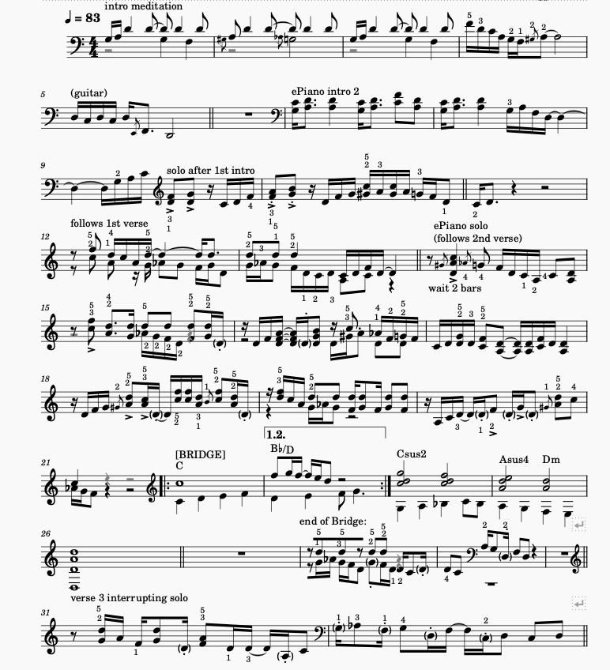

page 3

